PYTHON PROGRAMMING ASSIGNMENT REPORT
Design, Implement and Validate a Payment Calculator
for a Village Milk Co-operative

Course: CSA0806 – Python Programming
Student Name: ARUN . T
Register Number: 1912260643
Department :ECE
Faculty Name: HARIPRIYA
Submission Date: 23.10.26

Abstract
This report documents the analysis, design, implementation approach, and validation plan for a Python-based milk payment calculator for a village milk co-operative. The system accepts farmer and milk-quality data, calculates a rate from fat and solids-not-fat (SNF) readings, and computes the payment due. The assignment also considers numeric precision, input validation, functions, modules, algorithm tracing, testing, scaling, and a revised seasonal bonus rule. Evidence such as actual screenshots and measured benchmark results must be inserted by the student after running the submitted Python files.

Contents
- 1. Problem and Data Analysis
- 2. Numeric Types and Precision
- 3. Constants, Naming and Data Structures
- 4. Expressions and Rounding
- 5. Input Conversion and Validation
- 6. Function Design
- 7. Module Design
- 8. Algorithm, Pseudocode and UML
- 9. Implementation and Functional Testing
- 10. Performance and Scaling
- 11. Final Design Recommendation
- 12. Day-4 Design Challenge
- Appendix A: Evidence Checklist
- Appendix B: Submission Notes

System Overview and Requirements
The co-operative receives milk from approximately 300 farmers twice per day. The calculator uses milk quantity, fat percentage, SNF percentage, and shift information to calculate payment.
Parameter | Requirement / assumption
Base rate | ₹30.00 per litre at 3.5% fat and 8.5% SNF
Fat adjustment | ₹0.40 per litre for each 0.1 percentage-point difference from 3.5% fat
SNF adjustment | ₹0.30 per litre for each 0.1 percentage-point difference from 8.5% SNF
Precision | Payment must be accurate to the nearest paisa
Scale | 300, 6,000, and 150,000 farmers
Validation | Reject malformed and out-of-range inputs; use ranges specified by the assignment
Day-4 update | Apr–Jun base rate ₹32; fat step ₹0.45; >500 L in ten days earns ₹0.50/L bonus

Important interpretation: percentage-point steps are calculated relative to the stated reference values. The exact rounding policy (round each rate/payment or only the final total) must be stated consistently and checked against the instructor's specification.

Task 1 — Problem and Data Analysis

Inputs, outputs, constants and data types
Item | Suggested type | Validation / purpose
Farmer ID | str | Non-empty; preserve leading zeros if present
Milk quantity (litres) | Decimal or float | Must be positive; define permitted upper limit
Fat percentage | Decimal or float | Numeric and within the permitted analyser range
SNF percentage | Decimal or float | Numeric and within the permitted analyser range
Shift | str or enum-like value | Accept only defined shift labels, e.g. morning/evening
Base rate | Decimal | ₹30.00/L in the initial scenario
Rate adjustment steps | Decimal | ₹0.40 per 0.1 fat point; ₹0.30 per 0.1 SNF point
Outputs | Decimal / formatted string | Rate per litre and total payout, formatted to two decimals

Assumptions
- The fat and SNF readings are percentages, not fractions.
- A step is based on a 0.1 percentage-point difference from the reference value.
- Farmer and shift identifiers are stored with each entry so that payments can be audited.
- Invalid data must be rejected with a useful message rather than silently accepted.
- Use a clearly documented rounding policy for currency.

Alternative data representations
Separate variables are straightforward for a single entry but become repetitive for many farmers. A tuple or dictionary groups the fields for one record; a list of records supports batches. A dictionary with named keys is readable and extensible. Processing n records takes O(n) time. Storing all records takes O(n) space; calculating a running total without retaining records takes O(1) extra space.
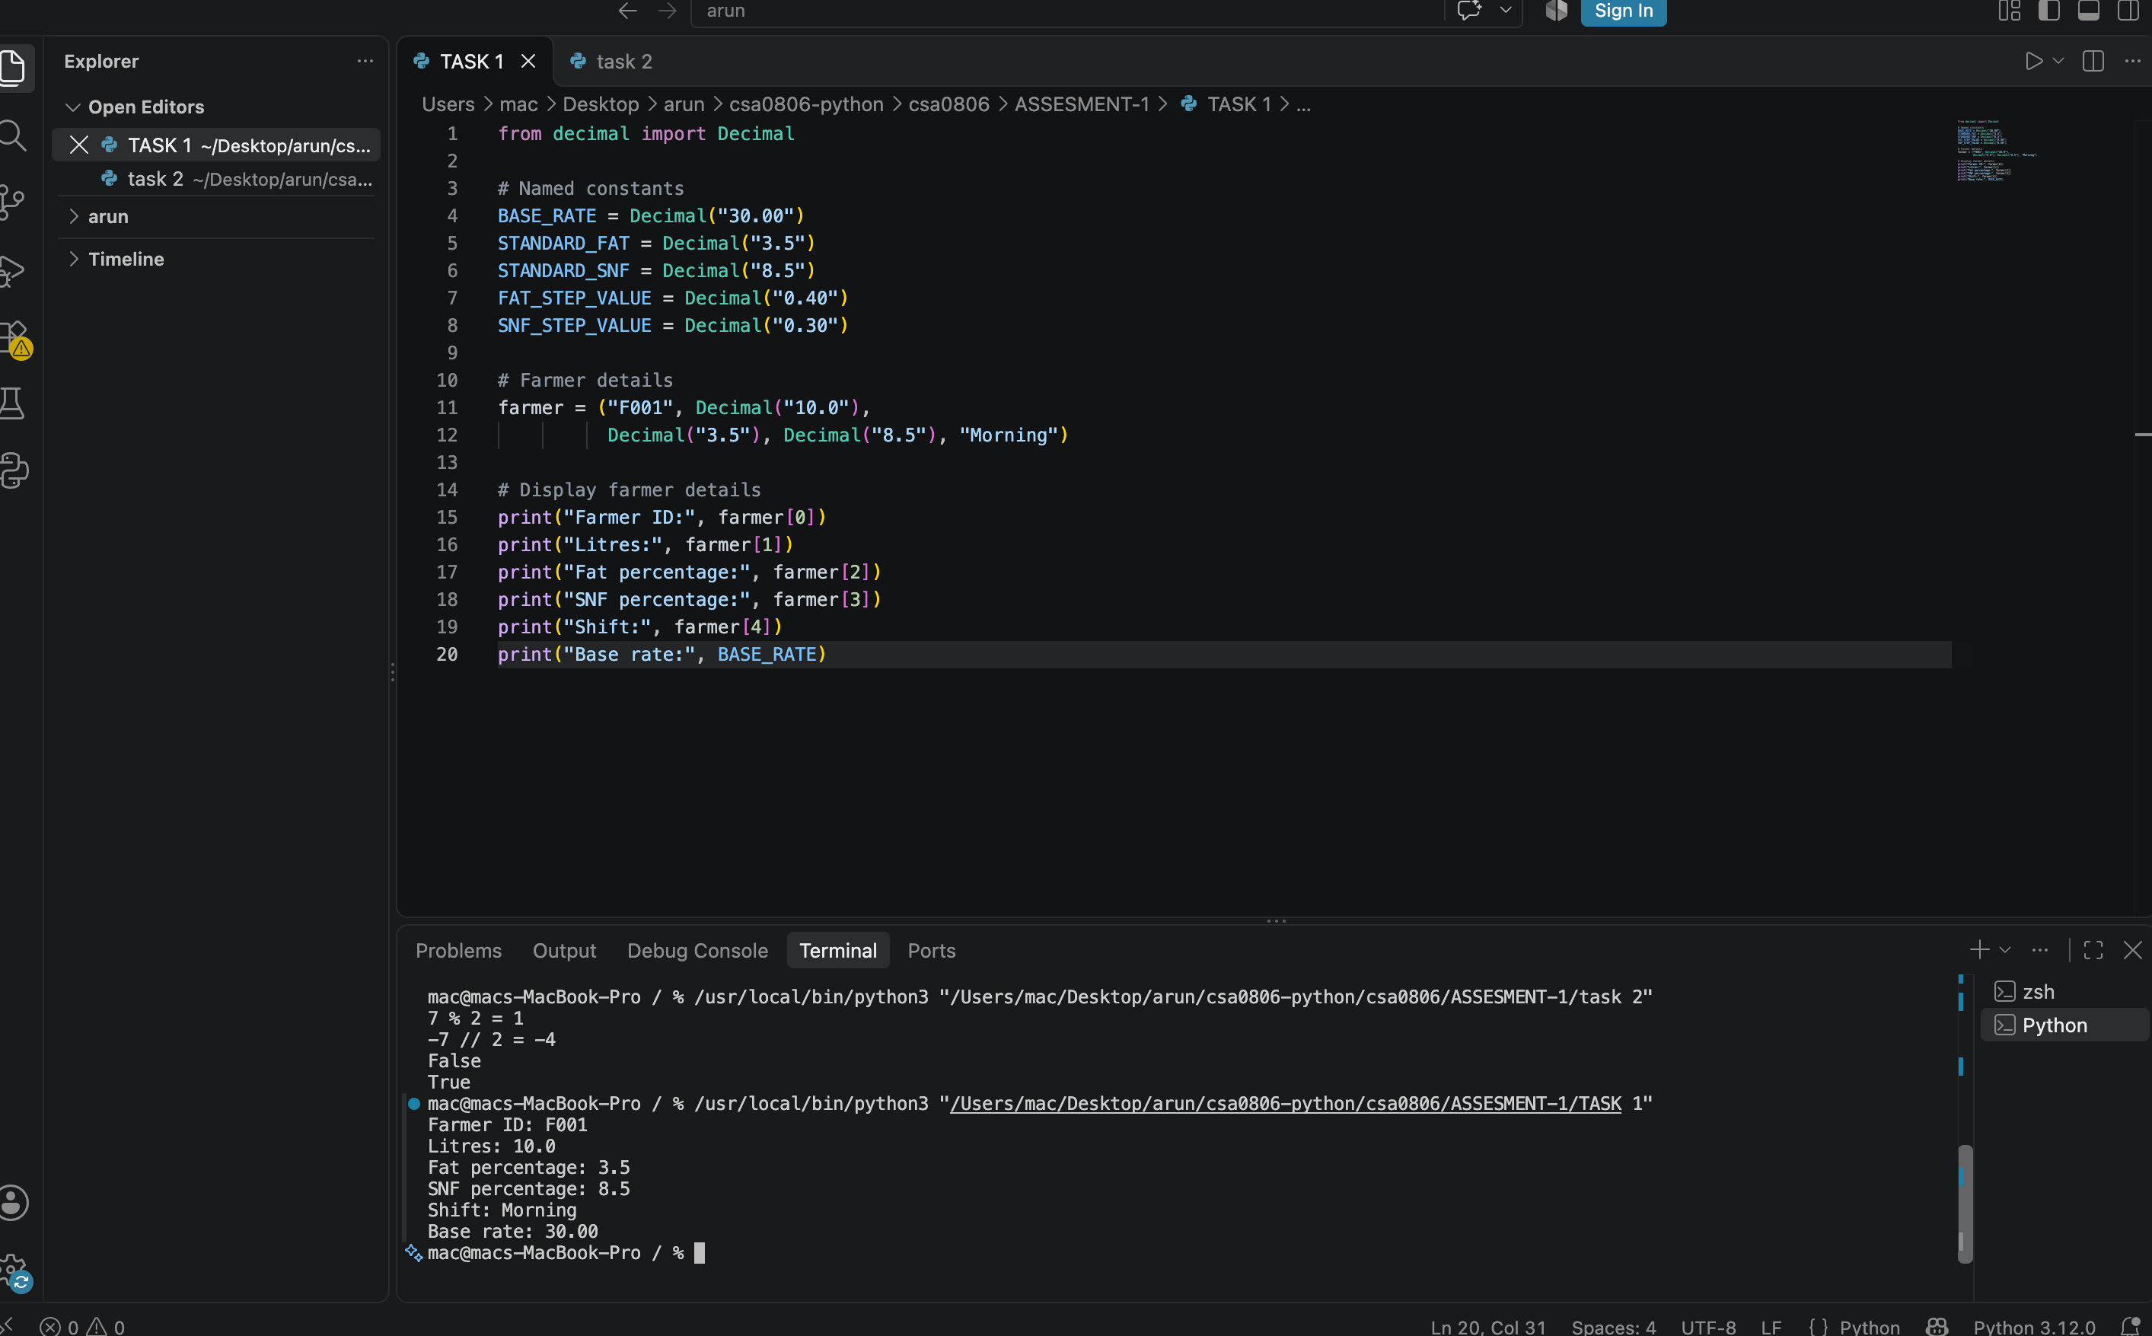

Task 2 — Numeric Types and Precision
Binary floating-point numbers cannot exactly represent many decimal fractions, which can cause small representation errors in values such as 0.1. Currency calculations should use Decimal constructed from strings, or integer paise, and apply a documented rounding rule.
from decimal import Decimal, ROUND_HALF_UP
amount = Decimal("12.345")
amount_paise = amount.quantize(Decimal("0.01"), rounding=ROUND_HALF_UP)
Approach | Advantages | Limitations
float + round | Simple and usually fast | Binary representation can create edge-case surprises
Decimal | Base-10 decimal arithmetic and explicit rounding | Usually slower than float
Integer paise | Exact integer arithmetic for currency amounts | Intermediate rate calculations may need scaled integers

Evidence to insert: run a short demonstration comparing 0.1 + 0.2 with Decimal('0.1') + Decimal('0.2'), and paste the actual terminal output here.
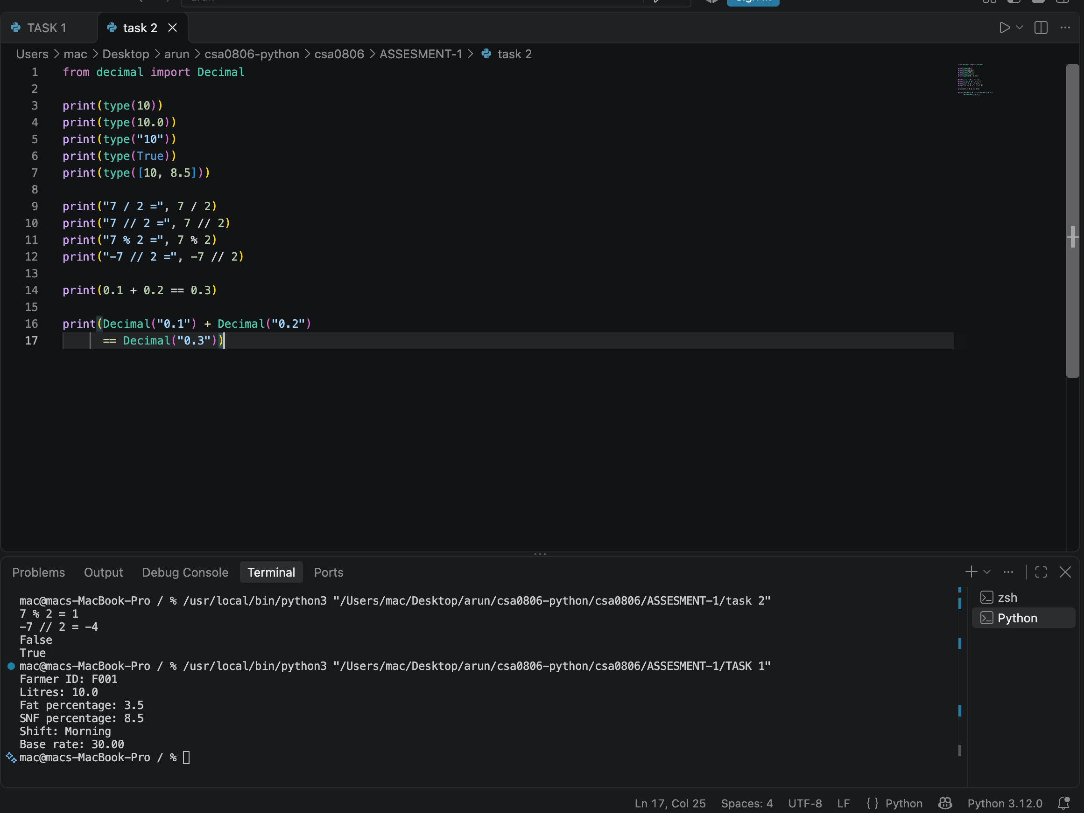

Task 3 — Constants, Naming and Data Structures
BASE_RATE = Decimal("30.00")
REFERENCE_FAT = Decimal("3.5")
REFERENCE_SNF = Decimal("8.5")
FAT_STEP_RATE = Decimal("0.40")
SNF_STEP_RATE = Decimal("0.30")
Named constants make policy visible and reduce errors caused by repeated magic numbers. Python is dynamically typed, so a variable can be rebound to a value of another type; this flexibility does not remove the need for clear names and validation. A configuration dictionary can group policy values.
RATES = {"base": Decimal("30.00"), "fat_step": Decimal("0.40"), "snf_step": Decimal("0.30")}
For swapping two variables in Python, use a, b = b, a. The assignment evaluates the right-hand side before assigning the two values.
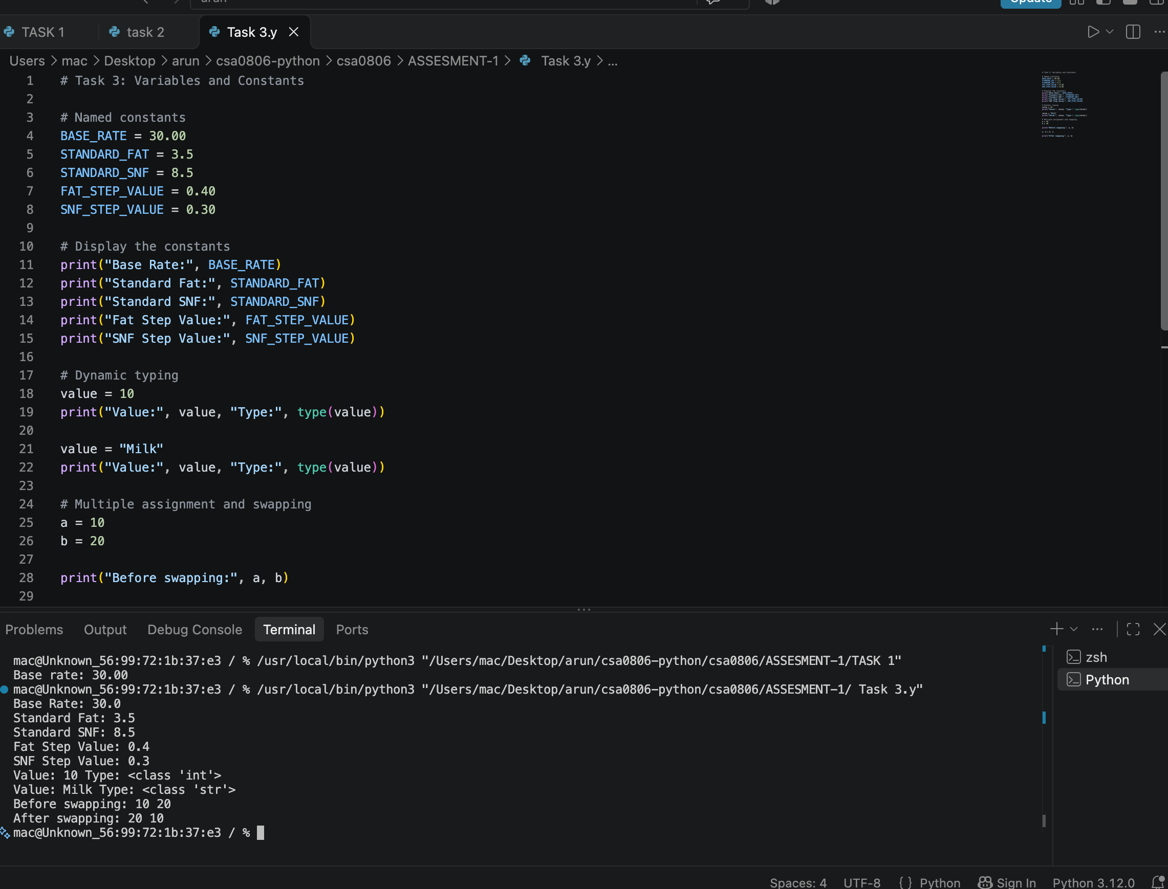

Task 4 — Expressions, Rate and Rounding

Rate model
fat_steps = (fat - REFERENCE_FAT) / Decimal('0.1')
snf_steps = (snf - REFERENCE_SNF) / Decimal('0.1')
rate = BASE_RATE + fat_steps * FAT_STEP_RATE + snf_steps * SNF_STEP_RATE
payout = litres * rate
This formula assumes the readings align with 0.1-point steps. If readings are not multiples of 0.1, the specification must clarify whether to round the number of steps or allow proportional adjustment. Do not use int() or floor division for currency unless truncation is explicitly required: they discard fractional parts. Format currency with two decimal places after applying the chosen rounding rule.
Operation | Effect
round(x, 2) | Rounds a numeric value to two decimal places using Python's built-in rounding semantics
int(x) | Truncates the fractional part toward zero
x // y | Floor division; rounds quotient down to an integer or lower multiple
Decimal.quantize(Decimal('0.01'), ROUND_HALF_UP) | Explicit two-decimal currency rounding

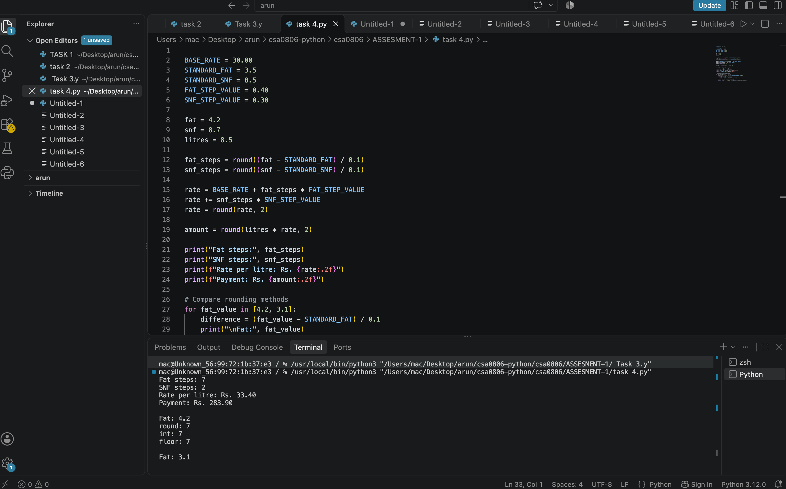

Task 5 — Input Conversion and Validation
input() returns a string. Convert numeric input only after stripping surrounding whitespace, and catch ValueError so text such as 'eight' or malformed decimal input such as '8,5' does not crash the program.
def read_number(prompt):
while True:
text = input(prompt).strip()
try:
return Decimal(text)
except InvalidOperation:
print('Invalid input. Enter a valid number.')
The exact valid ranges should match the assignment brief. Validate litres as positive, fat/SNF against the specified analyzer ranges, and shift against the permitted labels. Use f-strings such as f'{amount:.2f}' for display; for Decimal currency, quantize first and then format.
Evidence to insert: screenshots of one valid input, one malformed numeric input, and one out-of-range input.

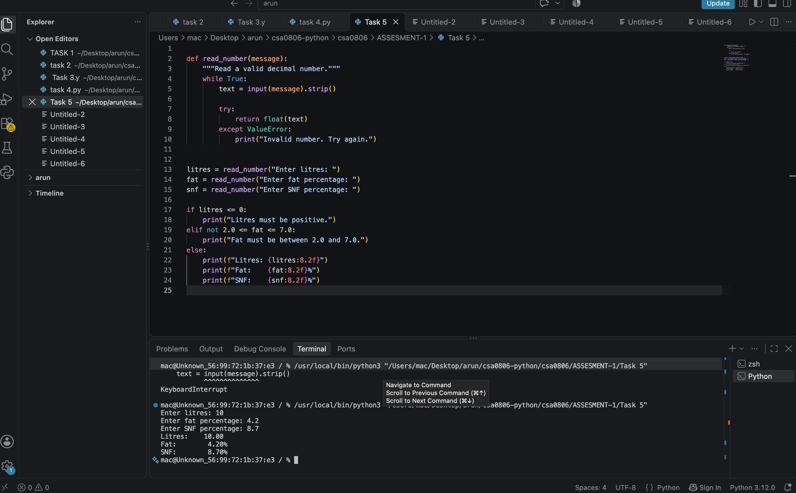Task 6 — Function Design
Recommended responsibilities:
- rate_per_litre(fat, snf) returns the calculated rate and does not print.
- payout(litres, rate) returns the rounded payment amount.
- ten_day_total(entries) totals a sequence of entries and returns the result.
- Input/output code remains separate from calculation logic.
Returning values makes functions reusable in tests and other modules. Printing is a user-interface side effect and should be kept at the program boundary. Local variables are scoped to their function unless explicitly returned or otherwise shared. Use docstrings to describe parameters, return values, units, and rounding behavior.
def payout(litres, rate):
"""Return the payment for a milk quantity and per-litre rate."""
return (litres * rate).quantize(Decimal("0.01"), rounding=ROUND_HALF_UP)
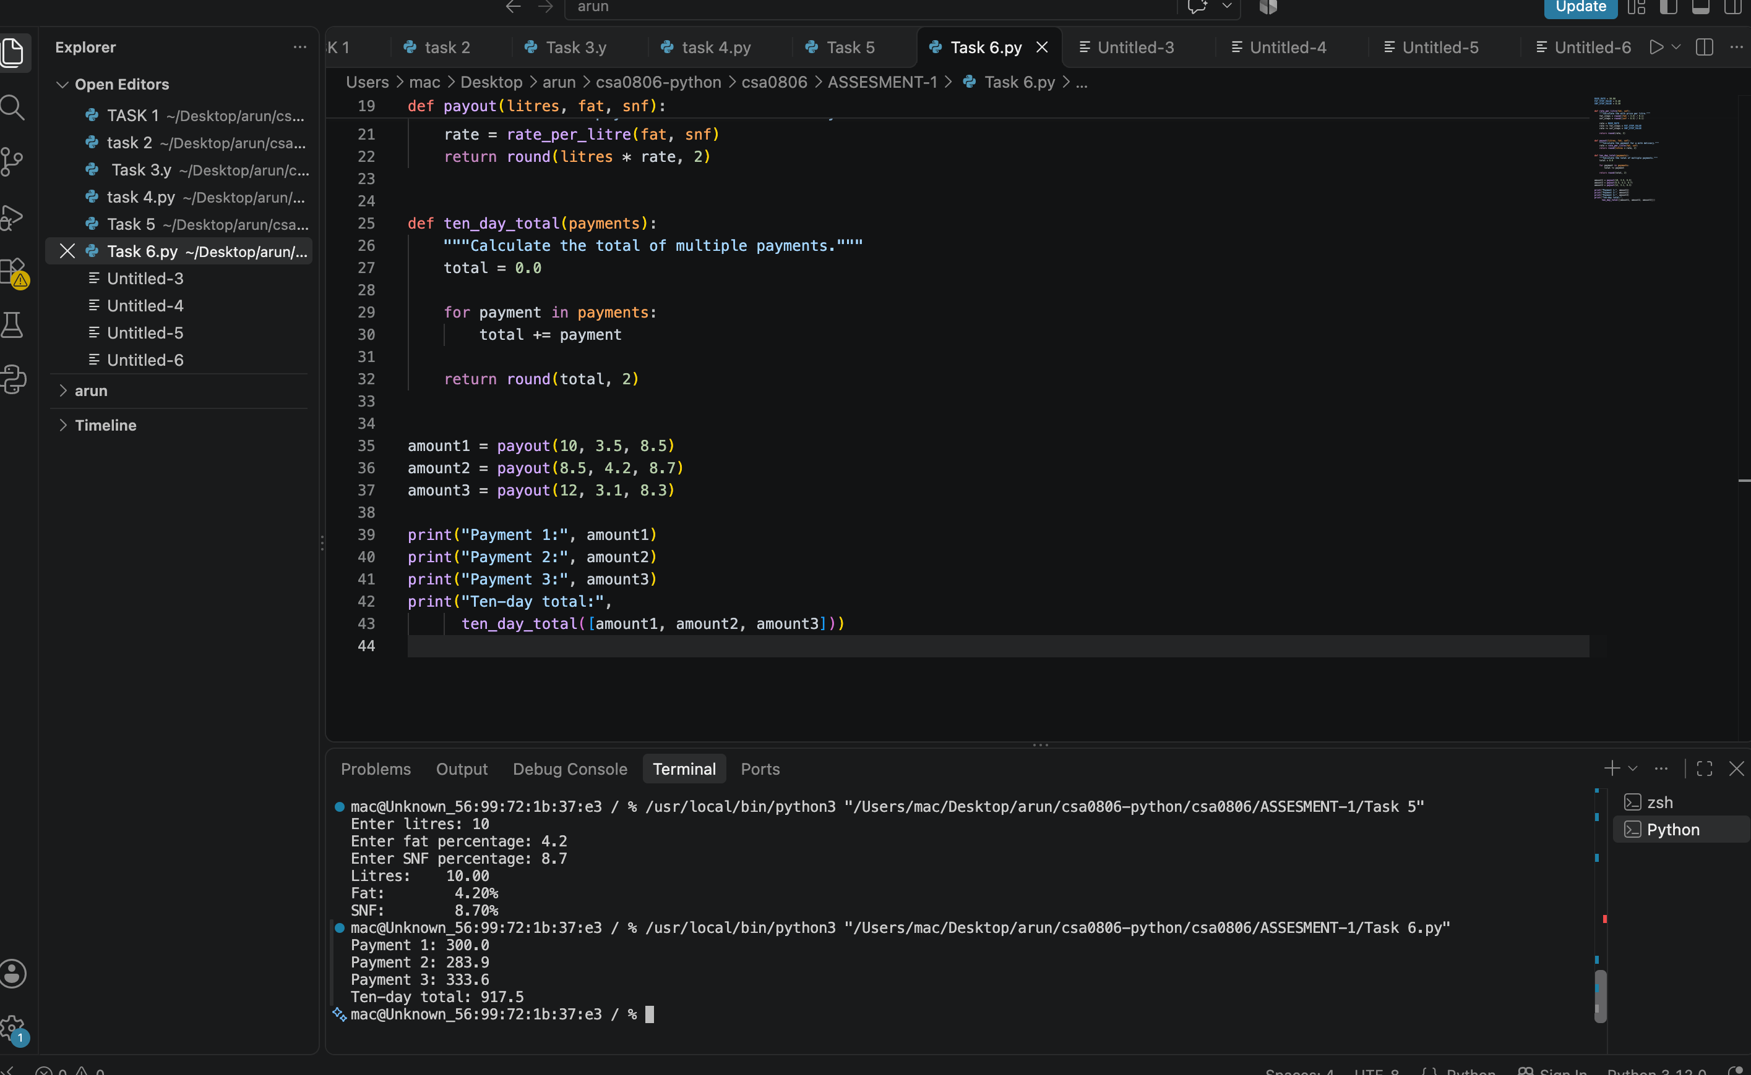

Task 7 — Module Design
Place reusable calculation functions in milkrate.py and the interactive driver in a separate script. Both files should be in the same directory unless the project is packaged as a module.
# milkrate.py
def rate_per_litre(fat, snf):
# calculate and return the rate
...

# task7.py
from milkrate import rate_per_litre

if __name__ == "__main__":
# read inputs and call imported functions
...
The if __name__ == '__main__' guard runs the driver only when the file is executed directly, not when imported. Replace the illustrative ellipses with the actual functions/code from the submitted files.
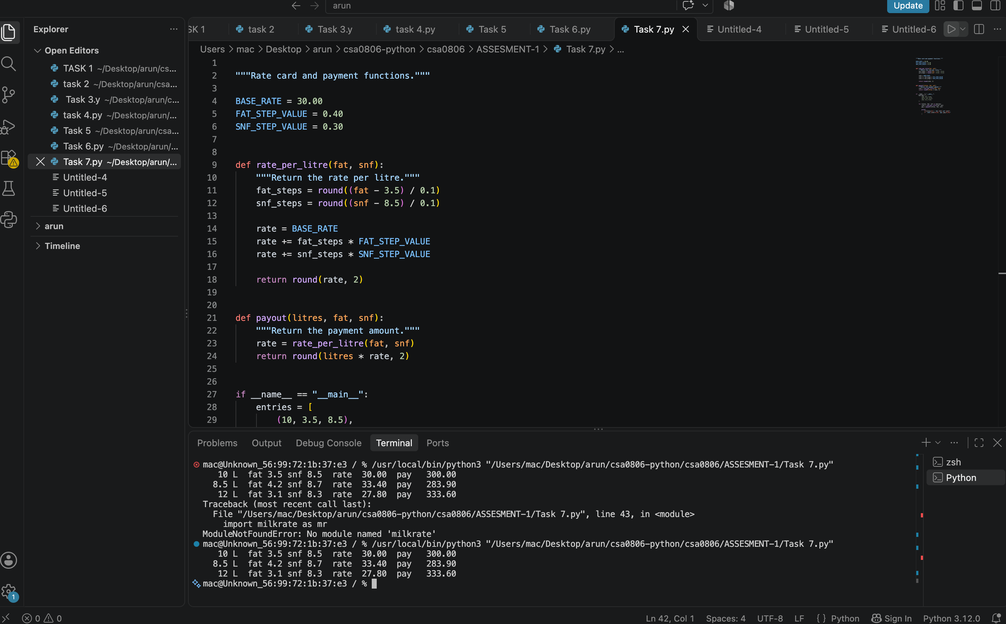
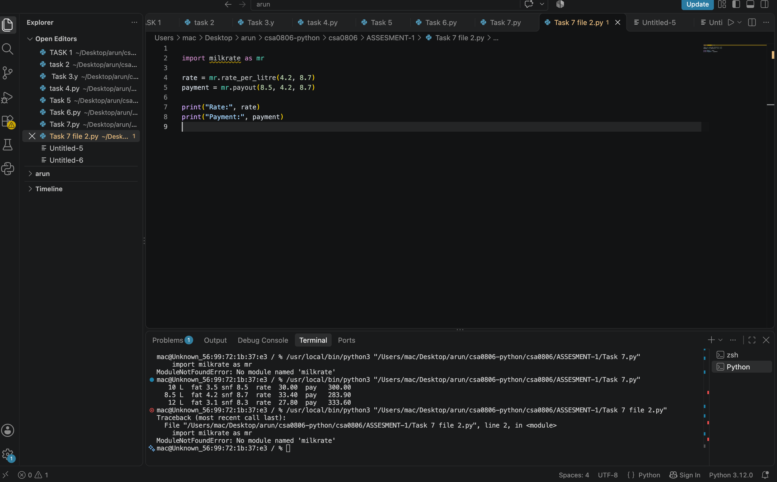

Task 8 — Algorithm, Pseudocode and UML

Pseudocode
START
Read farmer ID, litres, fat, SNF and shift.
Validate the input fields; if invalid, display an error and request valid data.
Calculate fat steps and SNF steps from the reference values.
Calculate rate per litre using the base rate and adjustments.
Calculate payout = litres × rate.
Round the payout according to the currency policy.
Display/store the farmer record and payout.
Repeat for remaining entries; calculate totals if required.
STOP

Text flowchart
[Start] -> [Read input] -> [Validate?]
| invalid -> [Show error / re-enter] -> [Read input]
| valid
v
[Calculate fat/SNF steps] -> [Calculate rate] -> [Calculate payout]
-> [Display/store result] -> [More entries?]
yes -> [Read input]
no -> [Display total] -> [End]

UML-style use case summary
Actor | Use case | Outcome
Co-operative operator | Enter farmer/milk details | Validated milk record
Co-operative operator | Calculate payment | Rate and payout
Co-operative operator | Review batch total | Total payment for selected entries
Developer/tester | Run test cases | Pass/fail evidence

UML-style class/module view
Operator -> MilkPaymentCalculator
MilkPaymentCalculator
+ rate_per_litre(fat, snf) : Decimal
+ payout(litres, rate) : Decimal
+ ten_day_total(entries) : Decimal
This is a conceptual UML-style view. If formal UML notation is required, recreate it using the standard actor/use-case and class diagram symbols and paste the diagram image into this section.
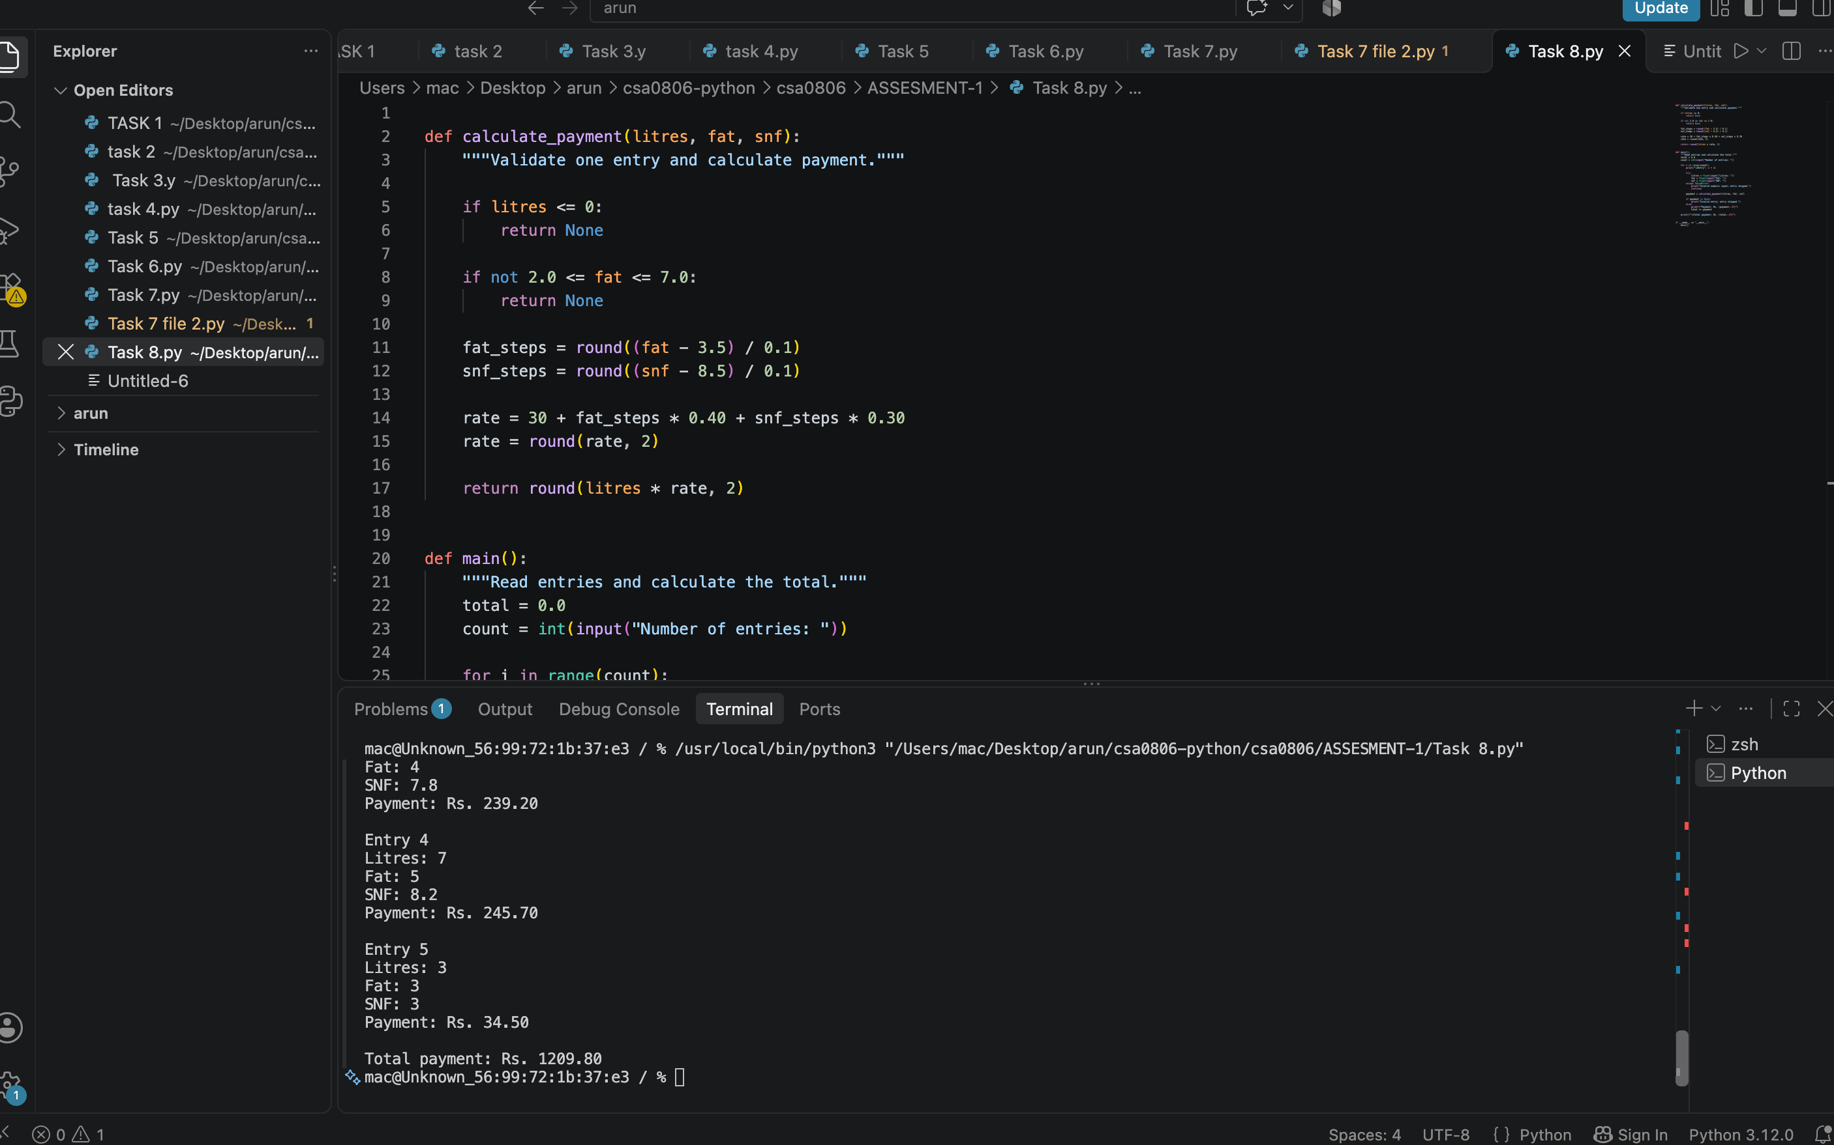

Task 9 — Full Calculator and Functional Tests
The integrated program should connect input validation, rate calculation, payout calculation, and result display. Use the exact submitted code as the implementation evidence; do not paste pseudocode in place of a required source listing.
Test ID | Test purpose | Input | Expected result / check | Actual result
T09-01 | Normal case | 10 L, 4.2% fat, 8.7% SNF | Valid rate and payout; two-decimal currency | Fill after run
T09-02 | Reference values | 10 L, 3.5% fat, 8.5% SNF | Rate = ₹30.00/L; payout = ₹300.00 | Fill after run
T09-03 | Zero litres | 0 L | Rejected if quantity must be positive | Fill after run
T09-04 | Negative litres | -1 L | Rejected | Fill after run
T09-05 | Malformed input | 'eight' litres | Validation message; no unhandled crash | Fill after run
T09-06 | Five records | Five valid entries | Each record processed; total equals sum of record payouts | Fill after run

Do not mark a test as passed until the program has actually been run and the observed output has been recorded.
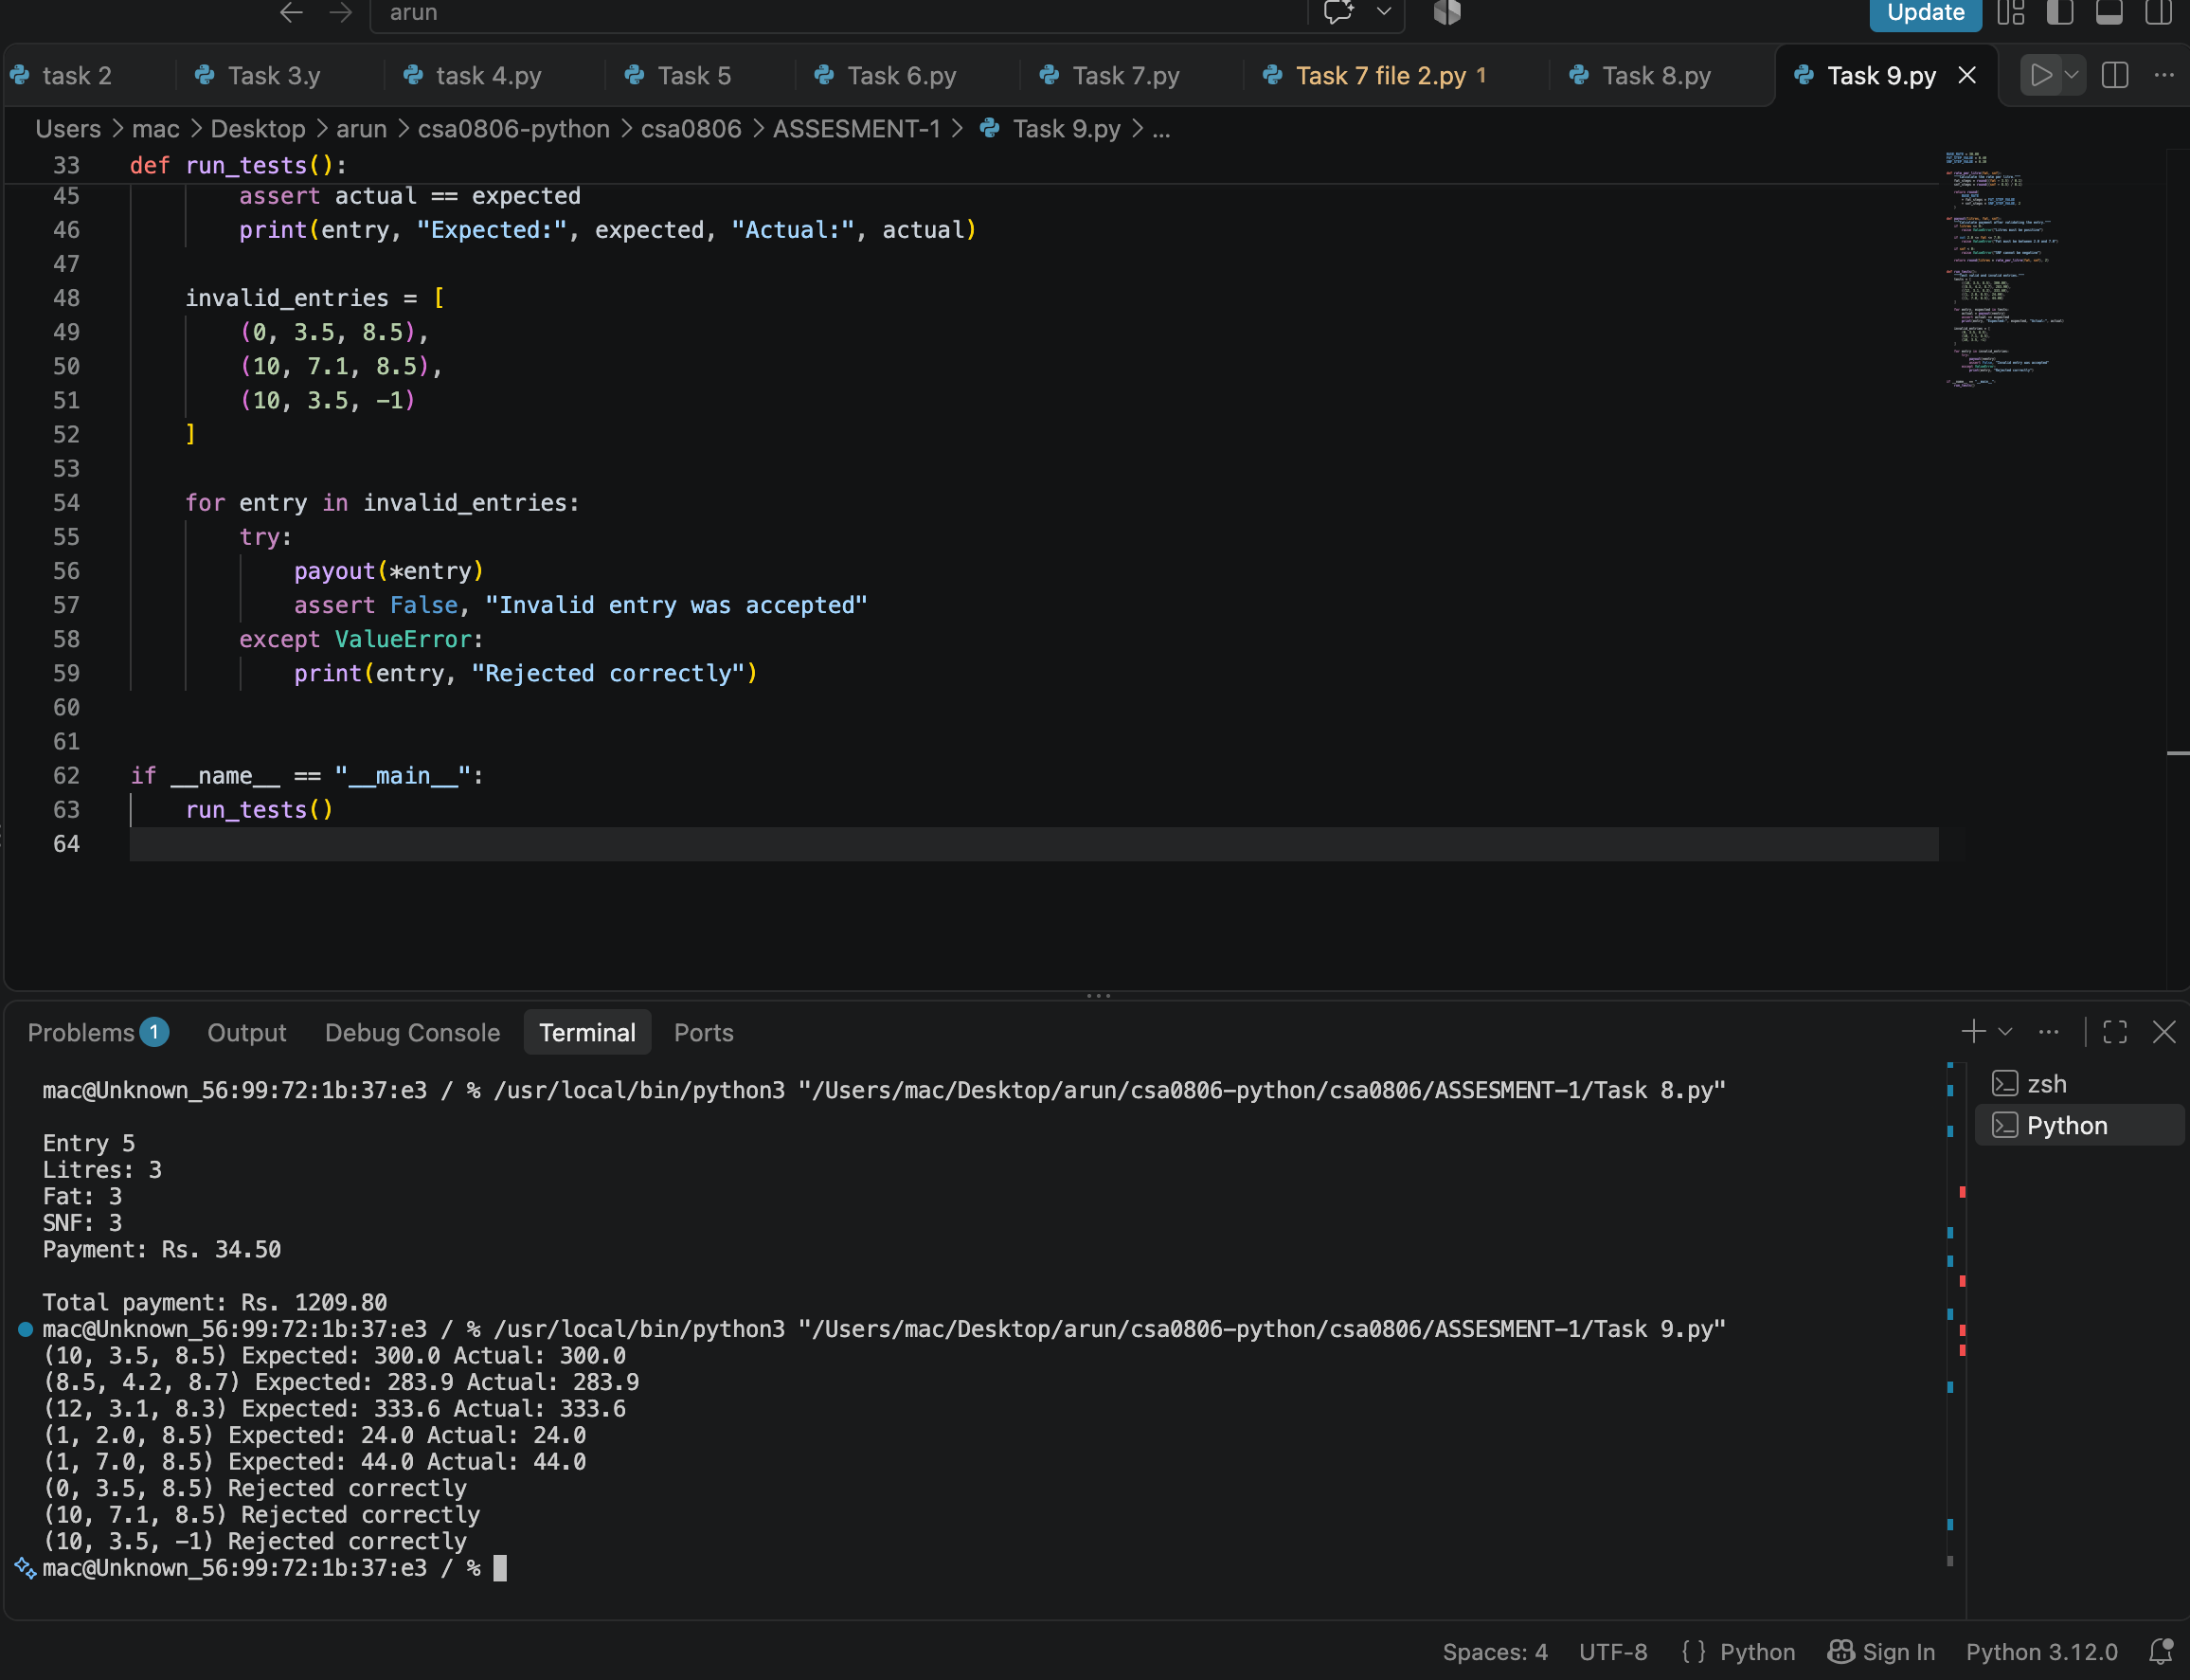

Task 10 — Performance, Scaling and Numeric Comparison
Benchmark float and Decimal implementations with the same generated dataset and equivalent rounding policy. Use time.perf_counter() around only the calculation loop, repeat the measurement, and report the median or average. Do not invent benchmark values: measure them on the target machine.
Number of farmers | Records per day at 2 shifts | Expected complexity for one pass | Measured time
300 | 600 | O(n) | Fill after run
6,000 | 12,000 | O(n) | Fill after run
150,000 | 300,000 | O(n) | Fill after run

For n records, a single calculation pass is O(n) time. Retaining every record requires O(n) storage; a streaming total requires O(1) extra storage. If using a cache/dictionary, explain the key, invalidation rule, and whether the calculation is repeated often enough to justify it.
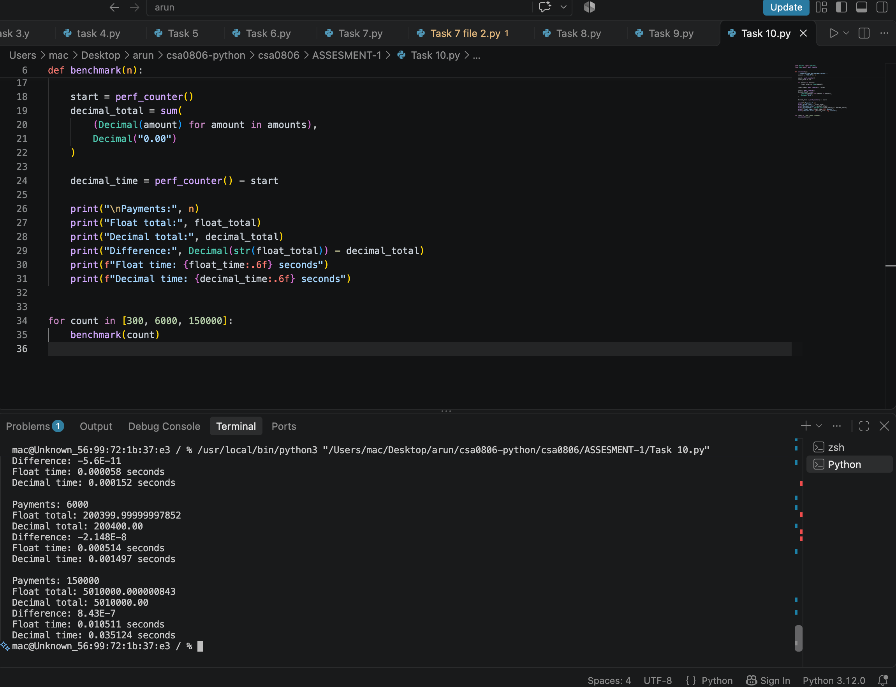

Task 11 — Final Design Recommendation
Design decision | Recommendation | Reason
Currency arithmetic | Decimal or integer paise | Avoid binary float representation issues in money
Policy values | Named constants/configuration | Avoid magic numbers; simplify policy changes
Code organization | Small functions in a reusable module | Testable, readable and maintainable
Data storage | List of records for batch reporting; stream for very large totals | Choose based on audit/reporting needs
Validation | Centralized validation functions | Consistent errors and data quality
Testing | Normal, boundary, invalid, and batch cases | Covers typical and failure behavior

The final choice should be supported by actual test output and the benchmark measurements from Task 10. If policy rates change by season, load the rate configuration from a clearly documented dictionary or configuration file rather than editing formulas in multiple places.
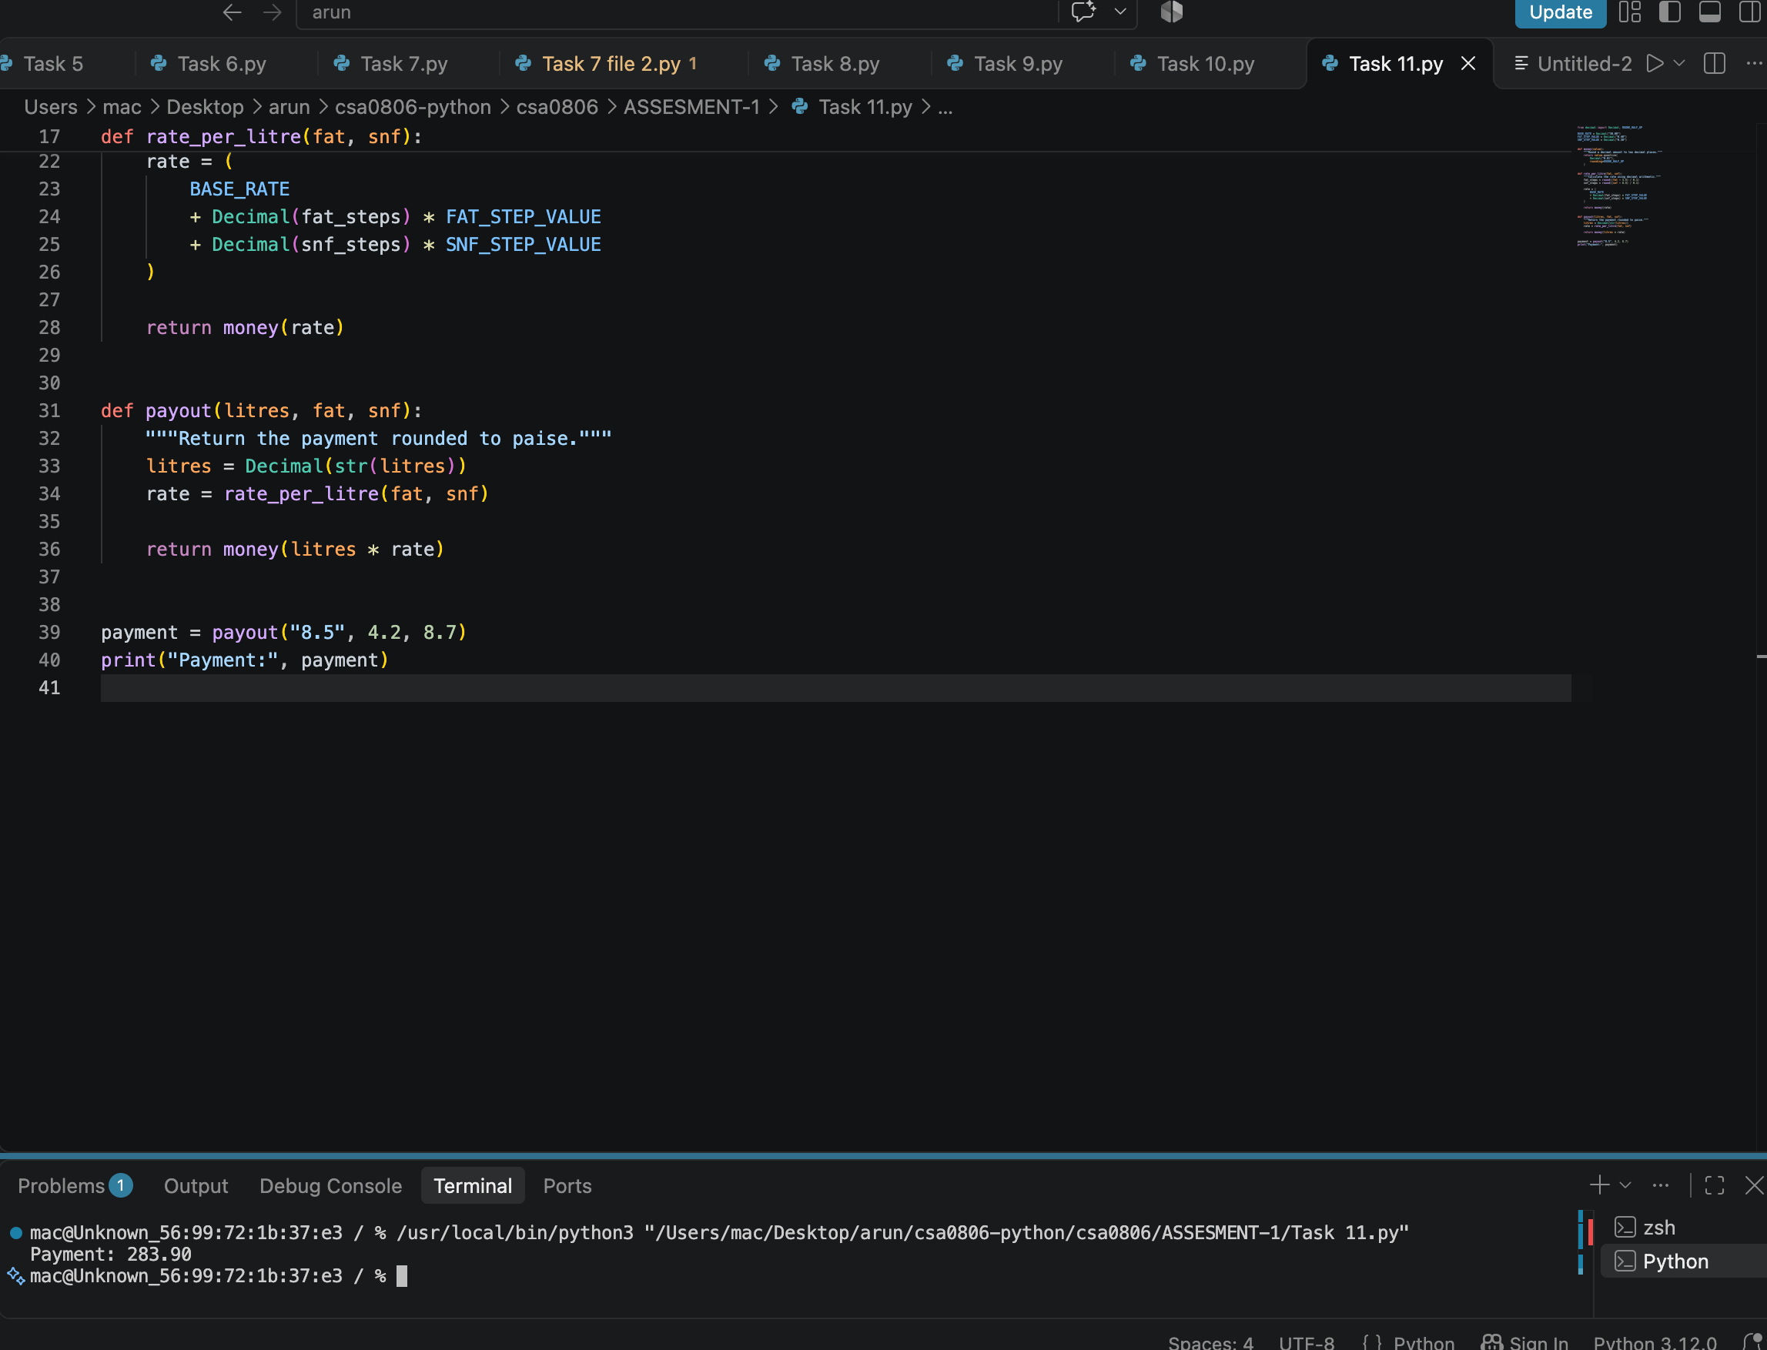

Task 12 — Day-4 Design Challenge

Updated business rules
- For April through June, the base rate is ₹32.00 per litre.
- Each 0.1 percentage-point fat step changes the rate by ₹0.45 per litre.
- A farmer supplying more than 500 litres over a ten-day period receives a bonus of ₹0.50 per litre.
- The original SNF adjustment is not explicitly stated as removed; confirm whether it remains active in the updated rules.

Algorithm
Collect each farmer's records over a ten-day window.
Sum litres for each farmer over that window.
Select the applicable seasonal base rate and fat adjustment.
Calculate the normal payout using the confirmed active quality adjustments.
If the farmer's ten-day total is greater than 500 litres, add ₹0.50 per eligible litre, according to the clarified bonus policy.
Round and report the final amount; retain the calculation breakdown for audit.

Challenge test table
Test ID | Ten-day total | Bonus eligibility | Expected check
T12-01 | 500.00 L | No | Strictly greater than 500 is not met
T12-02 | 500.01 L | Yes | Threshold exceeded
T12-03 | 501.00 L | Yes | Bonus applies per confirmed policy
T12-04 | Invalid/missing record | Cannot determine | Reject or flag incomplete data

Policy clarification required: the brief says farmers supplying more than 500 litres in ten days receive ₹0.50/L bonus. Confirm whether the bonus is applied to all litres supplied in the ten-day period or only litres above 500. Also confirm whether SNF adjustment remains active and how records crossing a month boundary are assigned to a season.

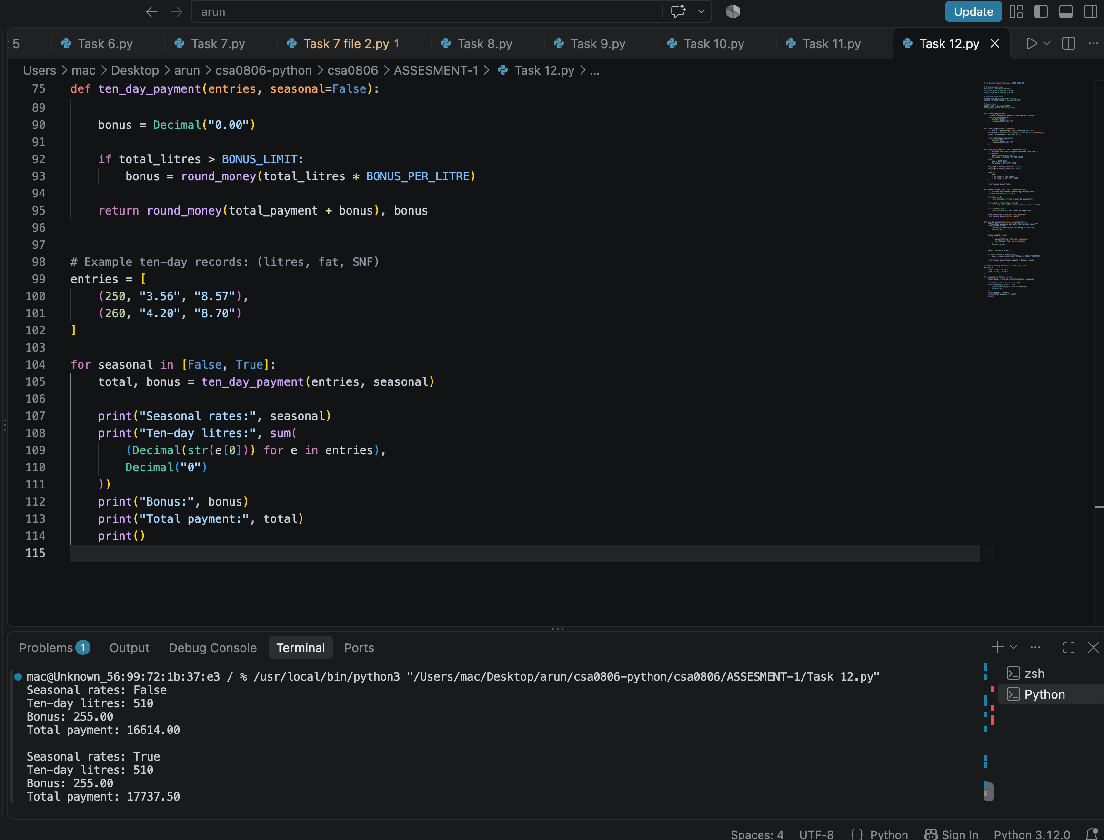

Appendix A — Evidence Checklist
Evidence item | What to attach | Status
Task 1 | Data dictionary, assumptions, complexity comparison | To complete
Task 2 | Float vs Decimal terminal output | To capture
Task 3 | Constants/configuration code evidence | To capture
Task 4 | Rate and rounding examples | To capture
Task 5 | Valid and invalid input screenshots | To capture
Task 6 | Function definitions and return-value test | To capture
Task 7 | Both module files and successful import output | To capture
Task 8 | Pseudocode, flowchart and UML diagram | Flowchart draft included; formal diagram may be needed
Task 9 | Completed test table with actual results | To run and complete
Task 10 | Timing results for all three scales | To measure
Task 11 | Design recommendation supported by evidence | Review after testing
Task 12 | Seasonal/bonus test output and clarified policy | To run and complete

Appendix B — Submission Notes
- Replace all blank student details on the cover page.
- Insert screenshots of the actual programs and outputs; do not present expected output as observed evidence.
- Replace illustrative code snippets with exact source code where the assignment requires implementation evidence.
- Complete the Actual result and Measured time columns after running the programs.
- Confirm exact requirements, valid ranges, rounding behavior, and Day-4 bonus interpretation against the original assignment brief.
- Ensure the final report is consistent with the actual Python files uploaded to GitHub.

Conclusion
The proposed calculator separates data collection, validation, rate computation, and reporting. Decimal or integer-based currency arithmetic, reusable functions, clear constants, modular code, and systematic testing improve correctness and maintainability. The final submission should include actual execution evidence and measured performance results so that every claim is traceable to the submitted implementation.

